This past weekend I traveled to Pennsylvania to compete in the B&P USA Masters Cup. After making it to the finals and to the semi-finals, I won the gold medal match and was named high overall champion of the match. Thank you to those at Keystone for making me feel so welcome and putting on a great match. Earlier this month I competed in the USA Spring Selection competition in Fort Benning, Georgia and placed sixth overall, after making the women's open finals the first round. I cannot thank everyone enough for the support they have showed me. This sport is a lot of fun and hard work does truly pay off. Looking forward to my next competition in May. 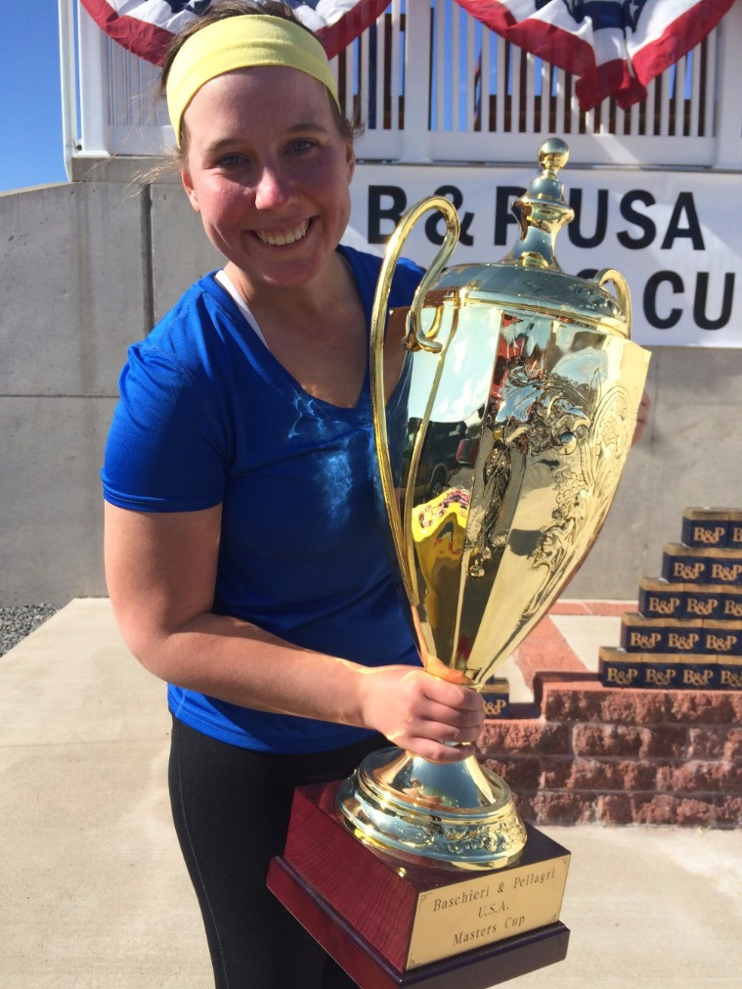

Hello,
My name is Emily Hampson and I am an Olympic dreamer. I fell in love with international trapshooting and compete in the sport competitively, shooting a Beretta DT-11. I first began my journey in eighth grade when my dad introduced me to the wonderful world of clay target shooting. I think I maybe hit like 7 targets that first day but it didn't matter, I was hooked.
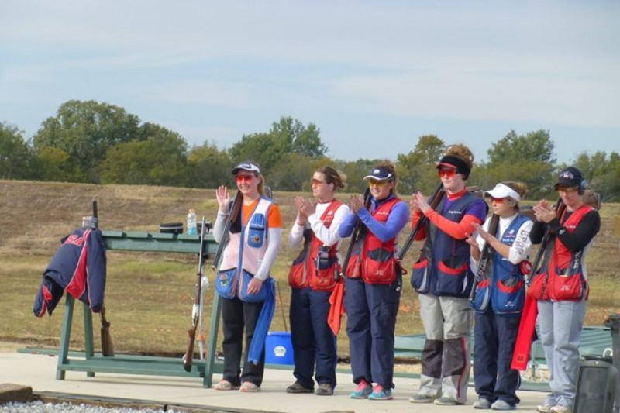
Now here I am, heading to shoot in the World Cup in Acapulco, Mexico in the beginning of March. I also plan to compete at the Spring Selection match in Georgia, the Fall Selection match in Arizona, the Junior Olympics and USA National Competition in Colorado, and various other competitions just this year alone.
As you can imagine, these shooting and travel expenses add up and I could use all of the help and support I can get! I hope you will consider supporting my dreams as I pursue my goal.
